**《Fundamentals of Electric Circuits》homework 4**

**5.14 Determine the output voltage *vo* in the circuit of Fig. 5.53.** (10’)

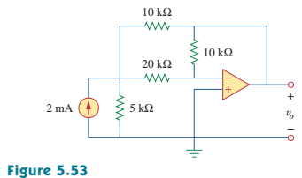

**5.15 (a) Determine the ratio *vo/is* in the op amp circuit of Fig. 5.54.**

**(b) Evaluate the ratio for *R1*= 20 *kΩ*, *R2*= 25 *kΩ*, *R3* = 40 *kΩ*.** (10’)

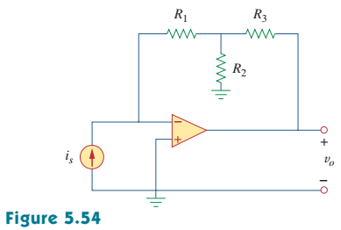

**5.23 For the op amp circuit in Fig. 5.61, find the voltage gain *vo/vs*.** (10’)

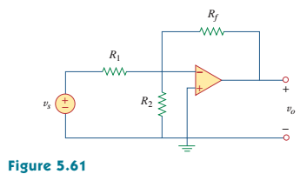

**5.30 In the circuit shown in Fig. 5.68, find *ix* and the power absorbed by the 20*kΩ* resistor.** (10’)

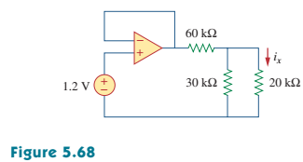

**5.32 Calculate *ix* and *vo* in the circuit of Fig. 5.70. Find the power dissipated by the 60*kΩ* resistor.** (10’)

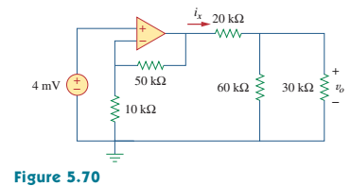

**5.40 Referring to the circuit shown in Fig. 5.77, determine *Vo* in terms of *V1* and *V2*.** (10’)

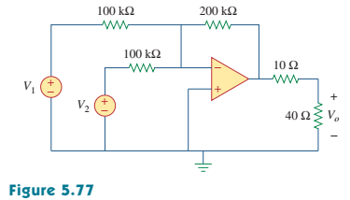

**5.47 The circuit in Fig. 5.79 is for a difference amplifier. Find *vo* given that *v1*=1 V and *v2*=2 V.**  (10’)

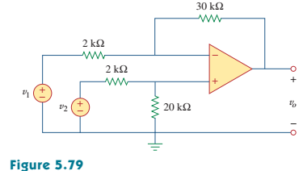

**5.57 Find *vo* in the op amp circuit of Fig. 5.84.**  (10’)

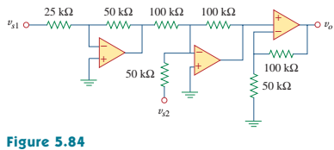

**5.64 For the op amp circuit shown in Fig. 5.91, find *vo/vs*.** (10’)

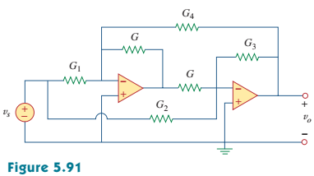

**5.90 The op amp circuit in Fig. 5.107 is a current amplifier. Find the current gain *io/is* of the amplifier.** (10’)

